# Siddhant Shreyans Mishrikotkar
#122B1F084

import random
def rail_fence_encrypt(text, rails):
if rails == 1:
return text
fence = [[] for _ in range(rails)]
rail = 0
direction = 1 # 1: down, -1: up
for char in text:
fence[rail].append(char)
rail += direction
if rail == 0 or rail == rails - 1:
direction *= -1
result = ''.join(''.join(row) for row in fence)
return result

def rail_fence_decrypt(cipher, rails):
if rails == 1:
return cipher
# Create an empty fence
fence = [['\n' for _ in range(len(cipher))] for _ in range(rails)]

# Mark the places with '*'
rail = 0
direction = 1
for i in range(len(cipher)):
fence[rail][i] = '*'
rail += direction
if rail == 0 or rail == rails - 1:
direction *= -1

# Fill the fence with cipher letters
index = 0
for r in range(rails):
for c in range(len(cipher)):
if fence[r][c] == '*' and index < len(cipher):
fence[r][c] = cipher[index]
index += 1

# Read the fence to reconstruct the text
result = []
rail = 0
direction = 1
for i in range(len(cipher)):
result.append(fence[rail][i])
rail += direction
if rail == 0 or rail == rails - 1:
direction *= -1
return ''.join(result)

def generate_key():
alphabet = list("ABCDEFGHIJKLMNOPQRSTUVWXYZ")
shuffled = alphabet[:]
random.shuffle(shuffled)
return ''.join(shuffled)

def monoalphabetic_cipher(text, key, mode):
alphabet = "ABCDEFGHIJKLMNOPQRSTUVWXYZ"
text = text.upper()
key = key.upper()

if len(key) != 26 or set(key) != set(alphabet):
print("Invalid key!")
return ""

if mode == 'e':
mapping = {alphabet[i]: key[i] for i in range(26)}
else:
mapping = {key[i]: alphabet[i] for i in range(26)}

result = ""
for char in text:
if char in mapping:
result += mapping[char]
else:
result += char
return result

def sorted_freq_letters(freq_dict):
return sorted(freq_dict, key=freq_dict.get, reverse=True)

def prepare_playfair_key(key):
key = key.upper().replace('J', 'I') # Replace J with I as per Playfair rules
seen = set()
result = ""
for char in key:
if char.isalpha() and char not in seen:
seen.add(char)
result += char
# Fill rest of alphabet (except J)
for char in "ABCDEFGHIKLMNOPQRSTUVWXYZ":
if char not in seen:
result += char
# Create 5x5 matrix
matrix = [list(result[i:i+5]) for i in range(0, 25, 5)]
return matrix

def find_position(matrix, char):
for i, row in enumerate(matrix):
for j, c in enumerate(row):
if c == char:
return i, j
return None

def process_text_playfair(text):
# Prepare text: uppercase, replace J with I, remove non-alpha, create pairs
text = text.upper().replace('J', 'I')
text = ''.join(filter(str.isalpha, text))
i = 0
pairs = []
while i < len(text):
a = text[i]
b = ''
if i + 1 < len(text):
b = text[i+1]
if a == b:
b = 'X'
i += 1
else:
i += 2
else:
b = 'X'
i += 1
pairs.append((a, b))
return pairs

def playfair_cipher(text, key, mode):
matrix = prepare_playfair_key(key)
pairs = process_text_playfair(text)
result = ""
for a, b in pairs:
r1, c1 = find_position(matrix, a)
r2, c2 = find_position(matrix, b)
if mode == 'e': # encrypt
if r1 == r2:
# Same row
result += matrix[r1][(c1 + 1) % 5]
result += matrix[r2][(c2 + 1) % 5]
elif c1 == c2:
# Same column
result += matrix[(r1 + 1) % 5][c1]
result += matrix[(r2 + 1) % 5][c2]
else:
# Rectangle
result += matrix[r1][c2]
result += matrix[r2][c1]
elif mode == 'd': # decrypt
if r1 == r2:
# Same row
result += matrix[r1][(c1 - 1) % 5]
result += matrix[r2][(c2 - 1) % 5]
elif c1 == c2:
# Same column
result += matrix[(r1 - 1) % 5][c1]
result += matrix[(r2 - 1) % 5][c2]
else:
# Rectangle
result += matrix[r1][c2]
result += matrix[r2][c1]
else:
print("Invalid mode! Use 'e' or 'd'.")
return ""
return result

def caesar_cipher(text, shift, mode):
result = ""
for char in text:
ascii_val = ord(char)
if mode == 'e':
shifted = (ascii_val + shift) % 128
elif mode == 'd':
shifted = (ascii_val - shift + 128) % 128
else:
print("Invalid Caesar mode! Use 'e' for encrypt or 'd' for decrypt.")
return ""
result += chr(shifted)
return result

def display_ascii_values(text):
return ' '.join(str(ord(c)) for c in text)

def PollyAlphabetic_cipher(text, key, mode):
text = text.upper()
key = key.upper()
result = ""
key_length = len(key)
alphabet = "ABCDEFGHIJKLMNOPQRSTUVWXYZ"

def shift_char(c, k, mode):
if c not in alphabet:
return c
text_idx = alphabet.index(c)
key_idx = alphabet.index(k)
if mode == 'e':
shifted_idx = (text_idx + key_idx) % 26
elif mode == 'd':
shifted_idx = (text_idx - key_idx) % 26
else:
return c
return alphabet[shifted_idx]

key_index = 0
for char in text:
if char in alphabet:
result += shift_char(char, key[key_index % key_length], mode)
key_index += 1
else:
result += char

return result

# Vernam Cipher Implementation
def vernam_cipher(text, key):
# Vernam cipher requires key to be same length as text
if len(text) != len(key):
raise ValueError("Key must be the same length as text for Vernam cipher.")
result = ""
for t, k in zip(text, key):
# XOR each character's ASCII value
result += chr(ord(t) ^ ord(k))
return result

def main():
# Example usages for each cipher
print("\n--- Substitution Techniques Examples ---")
# Caesar Cipher Example
caesar_text = "HELLO WORLD"
caesar_shift = 3
caesar_encrypted = caesar_cipher(caesar_text, caesar_shift, 'e')
caesar_decrypted = caesar_cipher(caesar_encrypted, caesar_shift, 'd')
print(f"Caesar Cipher: Text='{caesar_text}', Shift={caesar_shift}")
print(f"Encrypted: {caesar_encrypted}")
print(f"Decrypted: {caesar_decrypted}\n")

# Monoalphabetic Cipher Example
mono_text = "HELLO WORLD"
mono_key = generate_key()
mono_encrypted = monoalphabetic_cipher(mono_text, mono_key, 'e')
mono_decrypted = monoalphabetic_cipher(mono_encrypted, mono_key, 'd')
print(f"Monoalphabetic Cipher: Text='{mono_text}', Key='{mono_key}'")
print(f"Encrypted: {mono_encrypted}")
print(f"Decrypted: {mono_decrypted}\n")

# Polyalphabetic Cipher Example (Vigenere)
poly_text = "HELLO WORLD"
poly_key = "KEY"
poly_encrypted = PollyAlphabetic_cipher(poly_text, poly_key, 'e')
poly_decrypted = PollyAlphabetic_cipher(poly_encrypted, poly_key, 'd')
print(f"Polyalphabetic Cipher: Text='{poly_text}', Key='{poly_key}'")
print(f"Encrypted: {poly_encrypted}")
print(f"Decrypted: {poly_decrypted}\n")

print("--- Transposition Techniques Examples ---")
# Rail Fence Example
rail_text = "HELLO WORLD"
rail_rails = 3
rail_encrypted = rail_fence_encrypt(rail_text, rail_rails)
rail_decrypted = rail_fence_decrypt(rail_encrypted, rail_rails)
print(f"Rail Fence: Text='{rail_text}', Rails={rail_rails}")
print(f"Encrypted: {rail_encrypted}")
print(f"Decrypted: {rail_decrypted}\n")

# Vernam Cipher Example
vernam_text = "HELLO"
vernam_key = "XMCKL" # Key must be same length as text
vernam_encrypted = vernam_cipher(vernam_text, vernam_key)
# To decrypt, apply Vernam again with same key
vernam_decrypted = vernam_cipher(vernam_encrypted, vernam_key)
print(f"Vernam Cipher: Text='{vernam_text}', Key='{vernam_key}'")
print(f"Encrypted: {vernam_encrypted}")
print(f"Decrypted: {vernam_decrypted}\n")

while True:
print("\n=== Encryption Utility ===")
print("Select Algorithm:")
print("0. Exit")
print("Substitution Method ")
print("1. Caesar Cipher (ASCII-level)")
print("2. Monoalphabetic Cipher")
print("3. PolyAlphabetical Cipher")
print("4. Play Fair")
print("Transposition Method")
print("5. Rail Fense ")

algorithm_choice = input("Enter choice: ").strip()

match algorithm_choice:
case '1':
print("\n--- Caesar Cipher ---")
text = input("Enter text: ")
try:
shift = int(input("Enter shift value (integer): "))
except ValueError:
print("Shift must be an integer!")
continue
mode = input("Enter mode ('e' for encrypt, 'd' for decrypt): ").lower()

result = caesar_cipher(text, shift, mode)
if result:
print("Result (ASCII values):", display_ascii_values(result))
print("Shifted Text (as characters):", result)

key = input("To exit enter '1', to decrypt the result enter '2', or to continue enter '0': ")
if key == '1':
break
elif key == '2':
decrypted = caesar_cipher(result, shift, 'd')
print("Decrypted ASCII Values:", display_ascii_values(decrypted))
print("Decrypted Text:", decrypted)

case '2':
print("\n--- Monoalphabetic Cipher ---")
text = input("Enter text: ")

key = input("Enter 26-letter substitution key (A-Z exactly once) or leave empty to auto-generate: ").upper()

# If no key entered, generate a random one
if not key:
alphabet = list("ABCDEFGHIJKLMNOPQRSTUVWXYZ")
random.shuffle(alphabet)
key = ''.join(alphabet)
print(f"Generated key: {key}")

mode = input("Enter mode ('e' for encrypt, 'd' for decrypt): ").lower()

result = monoalphabetic_cipher(text, key, mode)
if result:
print("Result:", result)

key2 = input("To exit enter '1', to decrypt the result enter '2', or to continue enter '0': ")
if key2 == '1':
break
elif key2 == '2':
opposite_mode = 'd' if mode == 'e' else 'e'
decrypted = monoalphabetic_cipher(result, key, opposite_mode)
print("Decrypted Text:", decrypted) \

case '3':
print("\n--- PolyAlphabetical Cipher ---")
text = input("Enter text: ")
key = input("Enter key (letters only): ").upper()
if not key.isalpha():
print("Key must contain letters only!")
continue
mode = input("Enter mode ('e' for encrypt, 'd' for decrypt): ").lower()

result = PollyAlphabetic_cipher(text, key, mode)
if result:
print("Result:", result)

key2 = input("To exit enter '1', to decrypt the result enter '2', or to continue enter '0': ")
if key2 == '1':
break
elif key2 == '2':
decrypted = PollyAlphabetic_cipher(result, key, 'd')
print("Decrypted Text:", decrypted)
case '4':
print("\n--- Playfair Cipher ---")
text = input("Enter text: ")
key = input("Enter key (alphabetic only): ")
mode = input("Enter mode ('e' for encrypt, 'd' for decrypt): ").lower()

if not key.isalpha():
print("Key must be alphabetic only!")
break # or continue depending on your main loop

if mode not in ['e', 'd']:
print("Invalid mode! Please enter 'e' or 'd'.")
break

result = playfair_cipher(text, key, mode)
if result:
print("Result:", result)

key_input = input("To exit enter '1', to decrypt the result enter '2', or to continue enter '0': ")
if key_input == '1':
break
elif key_input == '2':
if mode == 'e':
decrypted = playfair_cipher(result, key, 'd')
print("Decrypted Text:", decrypted)
else:
print("Already decrypted!")

case '5':
print("\n--- Rail Fence Cipher ---")
text = input("Enter text: ")
try:
rails = int(input("Enter number of rails (integer > 1): "))
if rails < 2:
print("Number of rails must be greater than 1!")
break
except ValueError:
print("Number of rails must be an integer!")
break
mode = input("Enter mode ('e' for encrypt, 'd' for decrypt): ").lower()
if mode not in ['e', 'd']:
print("Invalid mode! Please enter 'e' or 'd'.")
break
if mode == 'e':
result = rail_fence_encrypt(text, rails)
else:
result = rail_fence_decrypt(text, rails)
print("Result:", result)
key_input = input("To exit enter '1', to switch mode enter '2', to try Vernam cipher enter '3', or to continue enter '0': ")
if key_input == '1':
break
elif key_input == '2':
mode = 'd' if mode == 'e' else 'e'
if mode == 'e':
result = rail_fence_encrypt(text, rails)
else:
result = rail_fence_decrypt(text, rails)
print(f"Switched mode ({mode}):", result)
elif key_input == '3':
print("\n--- Vernam Cipher ---")
vernam_text = input("Enter text (length N): ")
vernam_key = input("Enter key (length N): ")
if len(vernam_text) != len(vernam_key):
print("Key must be the same length as text!")
else:
vernam_encrypted = vernam_cipher(vernam_text, vernam_key)
print(f"Encrypted: {vernam_encrypted}")
vernam_decrypted = vernam_cipher(vernam_encrypted, vernam_key)
print(f"Decrypted: {vernam_decrypted}")
case '0':
print("Exiting...")
break

case _:
print("Invalid algorithm selection. Try again.")

if __name__ == "__main__":
main()

Ceaser Cipher

- 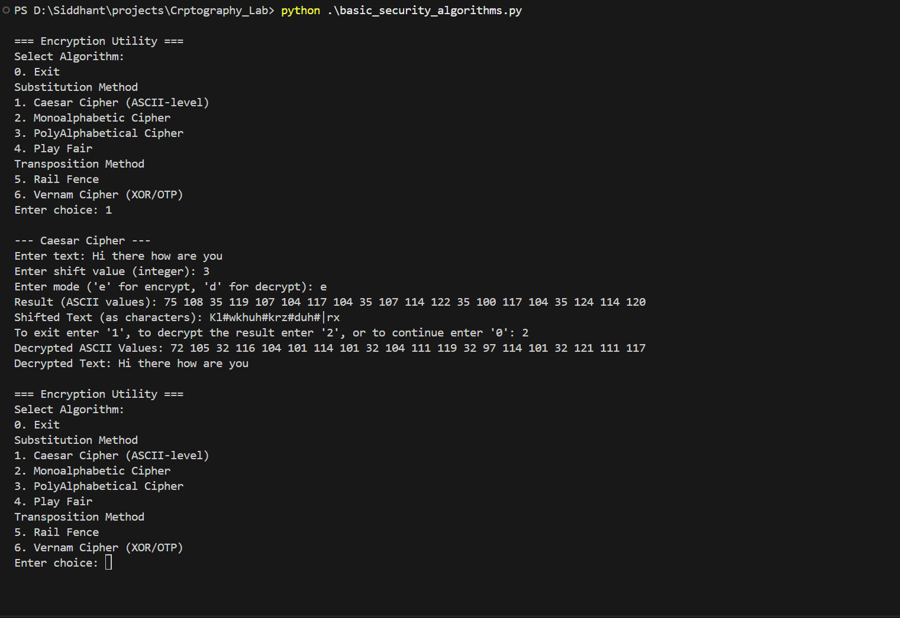

MonoA1phabetica1 Cipher

- 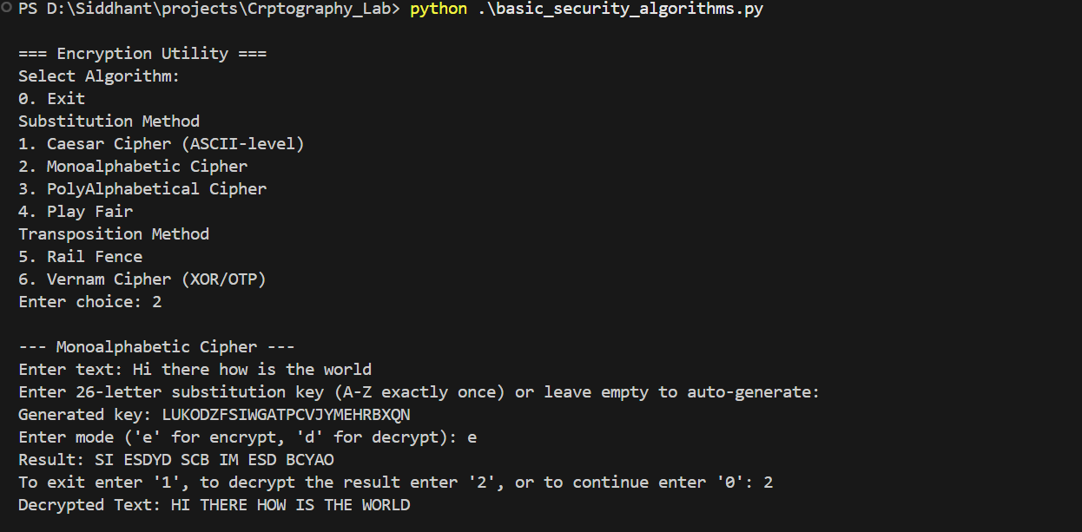

PolyA1phabetica1 Cipher
- 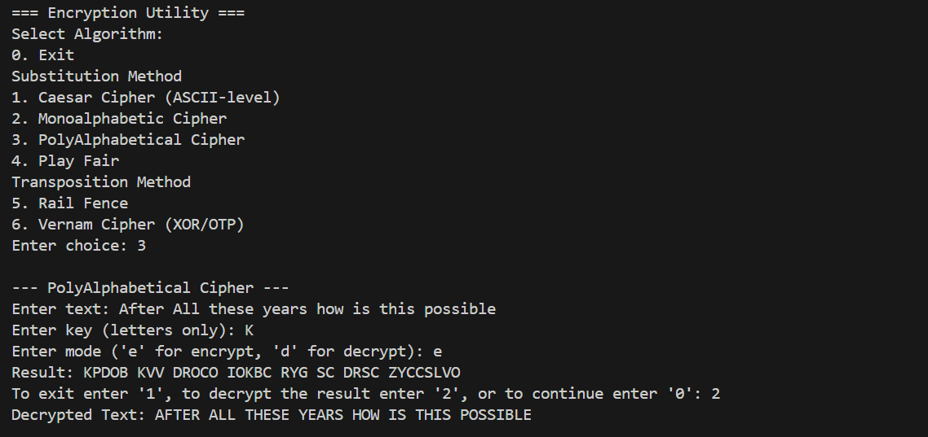

Verman Cipher

- 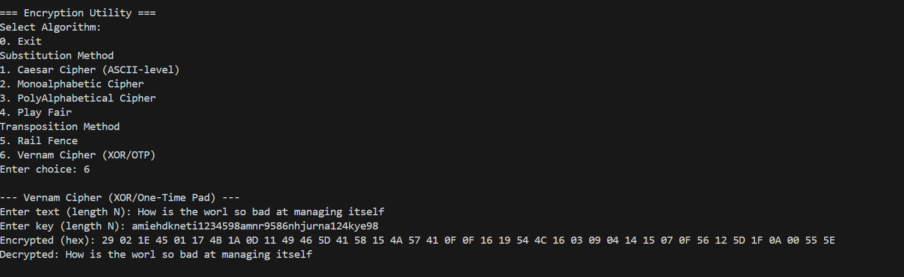

Play Fair cipher

- 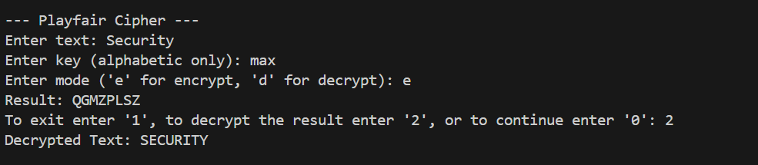

Rail Fens cipher

- 